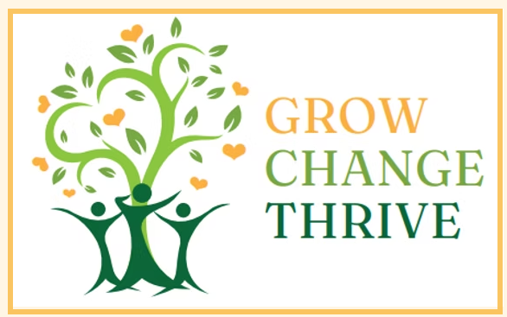 | FaithWorks Counseling  Dr. Debbie Harnois  2901 University Avenue, Suite 17  Columbus, GA 31907  706.366.9691  www.FaithWorksCounseling17.com

Am I Self-Sabotaging?
This handout is not about judging yourself. It’s about noticing patterns with curiosity and compassion. Everyone gets stuck sometimes — this helps you figure out why.
What Is Self-Sabotage?
Self-sabotage happens when our actions (or avoidance) get in the way of what we actually want or what would be healthy for us—often because of fear, overwhelm, or self-doubt.
Sometimes it looks like procrastination, avoidance, overthinking, or being hard on yourself.
Step 1: What Is the Situation?
What decision, goal, or situation are you feeling stuck on?
_______________________________________________________________________________________________
_______________________________________________________________________________________________
Step 2: What Do I Want Deep Down?
What is the outcome you truly want for yourself in this situation? (If you’re not sure, write not sure.)
_______________________________________________________________________________________________
_______________________________________________________________________________________________
Step 3: What Am I Doing Right Now?
Check any that apply:
☐ Avoiding the decision
☐ Overthinking or replaying it in my head
☐ Putting it off until I feel "ready"
☐ Telling myself I’ll mess it up
☐ Doing nothing because it feels safer
☐ Taking small steps forward
☐ Asking for help or information
☐ Other: _________________________________________________________________________________
Step 4: Is This Self-Sabotage or Self-Protection?
Sometimes waiting is not sabotage—it’s self-protection.
Answer honestly:
- Am I avoiding this because I’m scared, overwhelmed, or doubting myself?
☐ Yes ☐ No ☐ Not sure
- Am I giving myself time because this is a big decision that matters?
☐ Yes ☐ No ☐ Not sure
- Do I have enough information or support yet?
☐ Yes ☐ No ☐ Not sure
Step 5: What Thoughts Might Be Getting in the Way?
Check any thoughts you notice:
☐ “I’ll make the wrong choice.”
☐ “I should already know what to do.”
☐ “If I wait, that means I’m weak.”
☐ “If I decide, something bad will happen.”
☐ “I don’t trust myself.”
☐ Other thoughts: _________________________________________________________________________
Step 6: Reality Check
Answer these gently:
- Have I handled hard decisions before? ☐ Yes ☐ No ☐ Not sure
- Am I expecting myself to be perfect? ☐ Yes ☐ No ☐ Not sure
- Would I judge a friend this harshly? ☐ Yes ☐ No ☐ Not sure
Step 7: What Would a Small Healthy Step Look Like?
Self-sabotage usually looks like all-or-nothing thinking.
One small step I could take (not the final decision):
_______________________________________________________________________________________________
Examples:
- Getting more information
- Talking it through with someone safe
- Writing pros and cons
- Setting a future date to decide
Step 8: Self-Compassion Check
Finish one sentence:
- Even if I don’t decide today, I am still __________________________________________________________

Reminder
Not making a decision right now does not mean you are failing. Taking time can be part of making a thoughtful, healthy choice. Growth doesn’t mean rushing. It means listening to yourself with honesty and care.
Helpful Scripture
Trust in the Lord with all your heart and lean not on your own understanding: in all your ways submit to Him, and He will make your paths straight. Proverbs 3:5-6 (NIV)

He who began a good work in you will carry it onto completion.
Philippians 1:6 (NIV)

For God has not given us a spirit of fear, but of power, love and a sound mind.
2 Timothy 1:7 (NIV)

©2025 FaithWorks Counseling

